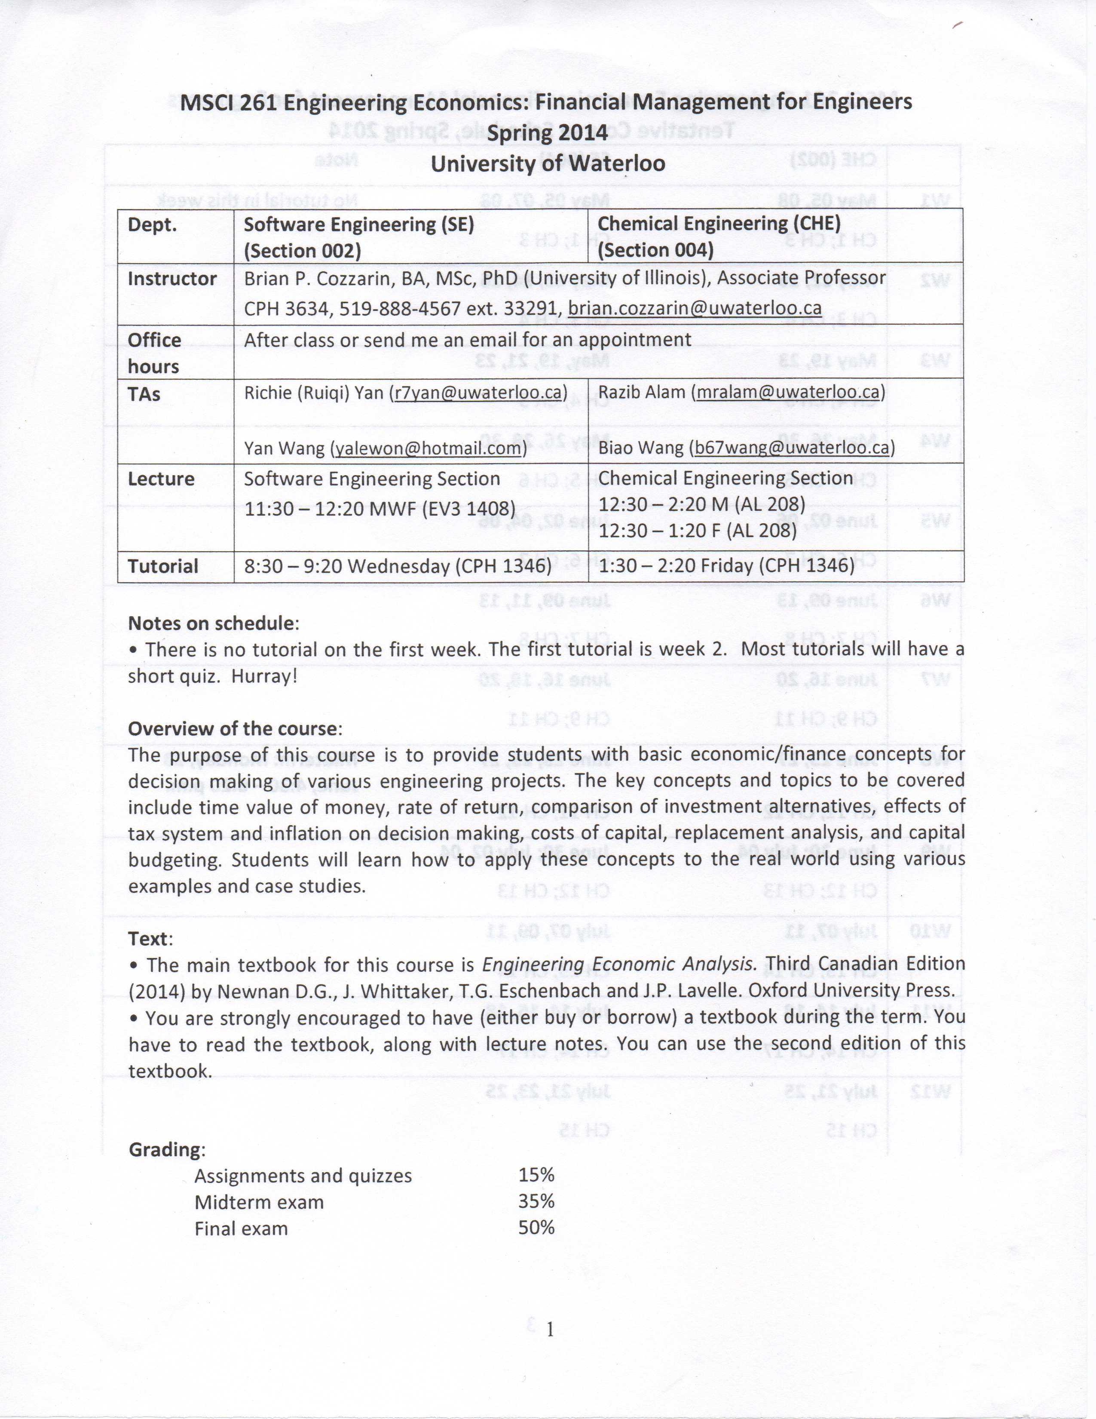

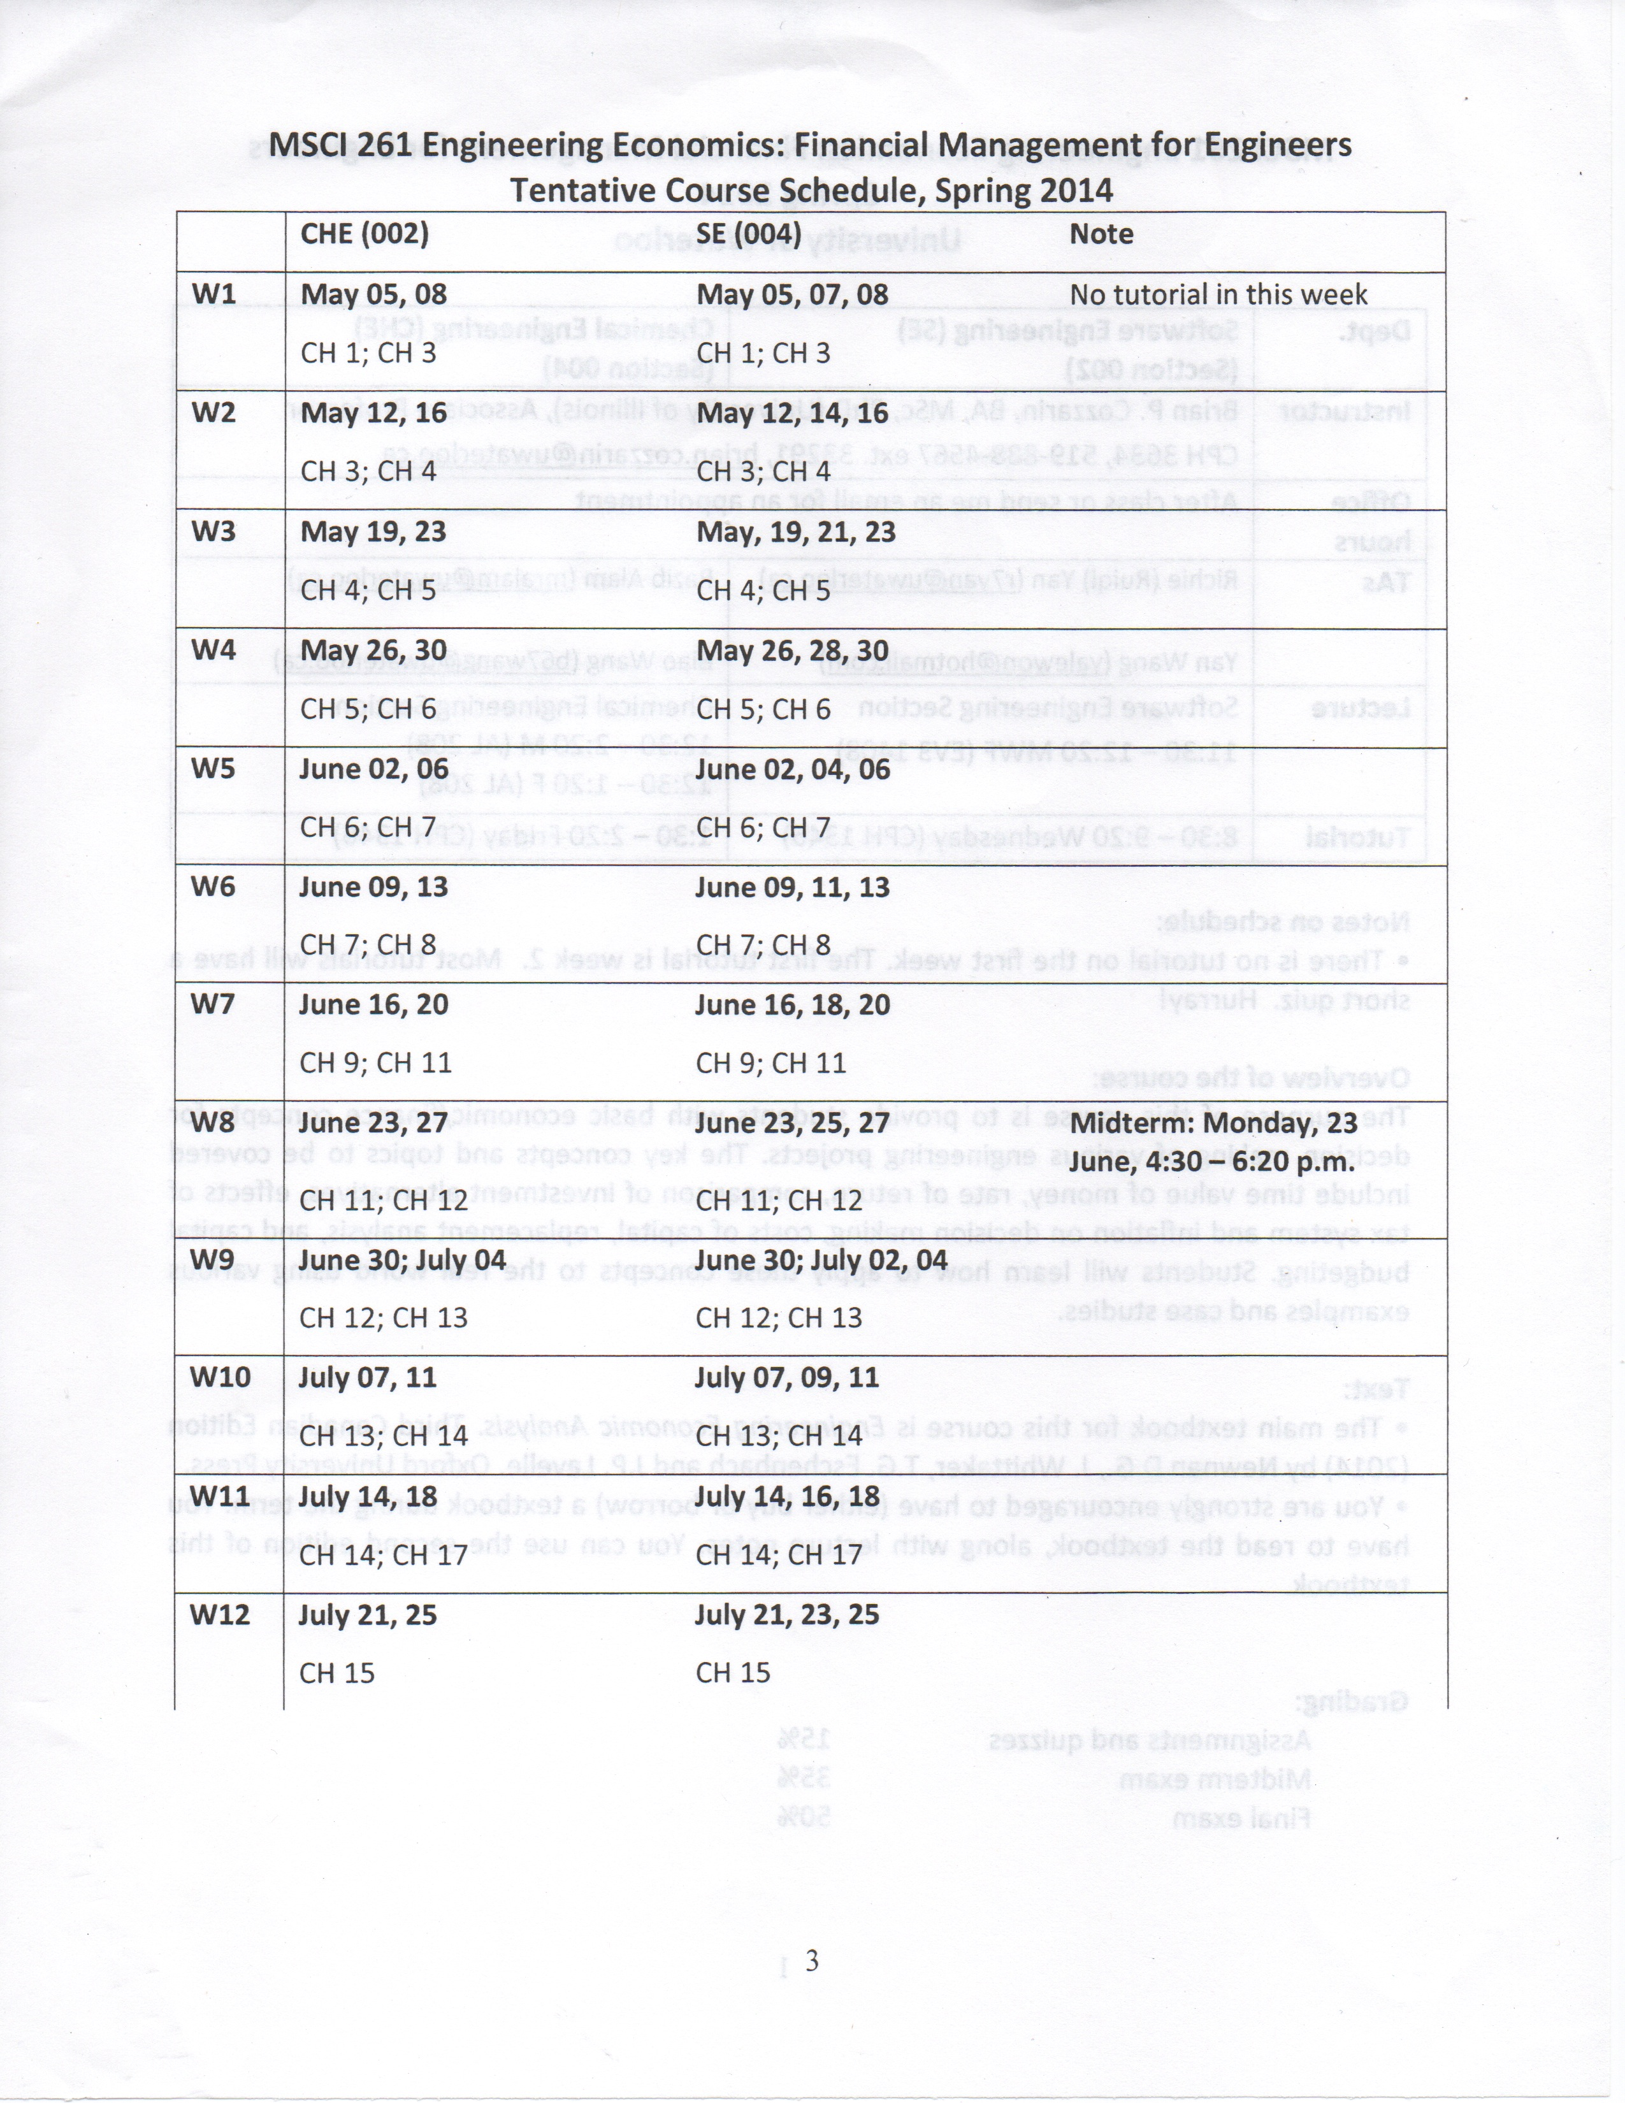

MSCI 261 – Engineers Economics

Brian P. Cozzarin

# Making Economic Decisions

* Boeing vs Airbus
  + In early 2000, Boeing has been working on development of the Sonic Cruiser
    - Lightweight plane that can fly near the speed of sound
    - Supposed to be about 15% faster than conventional jet
    - However, demand for plane was lukewarm
      * Not fuel efficient
      * Doesn’t fit enough people to make good profit
    - Boeing later switched to develop a slower, but more efficient 7E7 (later 787 Dreamliner) airplane
  + Airbus was betting on **size** rather than **speed**
    - New model A380 is the largest passenger plane in the world
    - By using new composite materials, Airubs REDUCED WEIGHT and MANUFACTURING COST by 20%
  + Comparing planes
    - Economic criteria
      * Cost (efficiency)
      * Size
      * Speed
      * Hub and spoke system
    - Economic factors
      * Maintenance
      * Purchase cost
      * Operating cost
      * Durability
      * Technological development
* What is engineering economics?
  + “Science that deals with techniques of **quantitative analysis** useful for selecting preferable **alternative** from several technically viable ones”
  + “Art of doing that well with **one dollar** what any bungler can do with **two**”
  + “The study of **making a decision** among several alternatives”
    - In personal life, we always make decisions, even unconsciously
    - In business environments, one’s decision has a significant impact on the survival of a firm
    - Engineering economic analysis provides tools in comparing alternatives to make better decisions
* Decision making problems
  + We are surrounded by a sea of problems
    - Simple (but important)
      * Should I pay cash or use credit cards?
    - Intermediate:
      * Should I buy or lease my next car?
    - Complex
      * Is a new automobile plant feasible?
  + We will focus on the second and third problems in in this course
  + More complex problems require systematic analysis, because
    - They are **important** enough to justify serious analysis
    - They involve various **economic aspects** in reaching a decision
  + In may business environment, costs, revenue and benefits occur at **different times**
    - In a new automobile design, the development costs occur now
    - However, benefits (or revenues) fro a new automobile begin only after the automobile is successfully manufactured
* Engineering economic analysis
  + **Engineering economic analysis:** the economic analysis of costs, benefits, and revenues occurring over time
  + Questions
    - Which engineering projects are WORTHWHILE?
    - Which engineering projects should have a higher PRIORITY?
    - How should the engineering project be DESIGNED?
    - How to achieve financial LONG-TIME GOALS?
* Decision making process
  + Formulate a problem or project
    - Recognize problem
    - Define the goals or objectives
    - Eg:
      * Material or process selection
      * Equipment investment or replacement
      * New product development
  + Identify several TECHNICALLY feasible alternatives for the problem
  + Choose an ECONOMICALLY preferable alternative
* Why study engineering economics?
  + Required course of Faculty of Engineering
  + Required by CEAB for PEng
  + Required if you are a manager in a company